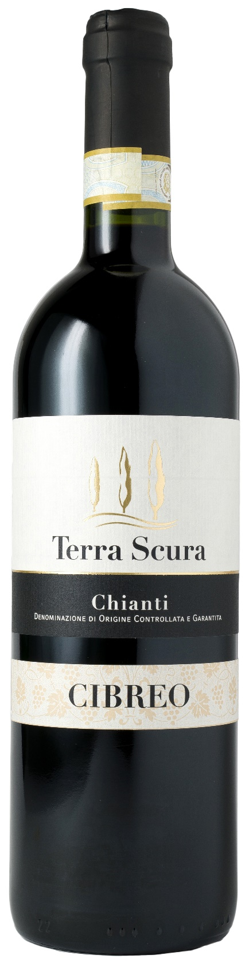
CHIANTI DOCG – CIBREO

Grape: Sangiovese 100%
Alc. Vol.%: 12,5
Vintage: 2024
Residual sugar g/l: 4,5
Total acidity g/l: 5,8
Region: Tuscany
Production zone: Vineyards in the province of Florence
Capacity: 750ml, 1500ml

CHARACTERISTICS

Vinification: Traditional peel maceration at a controlled temperature
Aging: At least 6 months in steel tanks
Yield per ha: 9000kg
Colour: Ruby red with garnet reflections
Bouquet: Soft, elegant, and fruity with notes of cherries
Flavour: Dry, smooth and pleasantly tannic with a long-lasting finish

SERVING SUGGESTIONS

Best enjoyed with pasta, red meat and game.
Serving temperature 18 °C
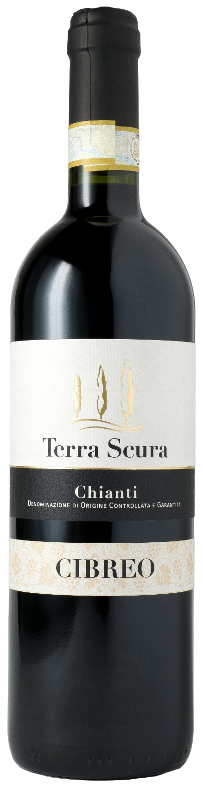
TECHNICAL INFORMATION / PALLETIZING

Size 750ml:
Article Nr. V07002A
GTIN-13 bottle 8017868000440
GTIN-13 carton 8017868004233
Closure Cork
Bottles / carton 6 bottles
Pallet size 80x120cm
Cartons/layer 24
Cartons/pallet 120
Kg/carton 7,8
Kg/pallet 958

Size 1500ml:
Article Nr. V07001B
GTIN-13 bottle 8017868001782
GTIN-13 carton 8017868004578
Closure Cork
Bottles / carton 6 bottles
Pallet size 80x120cm
Cartons/layer 14
Cartons/pallet 56
Kg/carton 13,4
Kg/pallet 790

Contains sulphites
GMO Free
Revisione 01. 09.05.2024

